Newsletter No 13 January 2024

‘Life is a Series of Thousands of Tiny Miracles. Notice Them.’
Roald Dahl
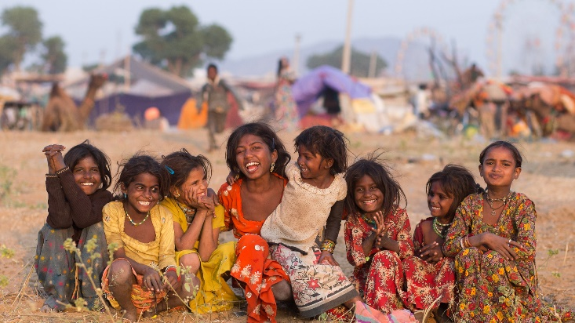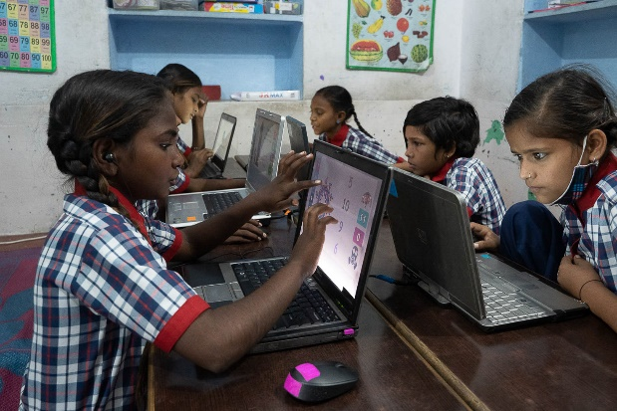
Always Amazed

Sue visited our schools and projects in Pushkar in October and November and, as always, was amazed not only by the enduring quality of the education and care which all staff in our three partnership schools and traineeships provide, but also by the wonderful enthusiasm and positivity which she continues to find among our pupils and trainees. Sue paid many visits to pupils and staff at all three schools, as well as to staff and our sponsored trainees at the award-winning Tree Of Life For Animals (TOLFA) animal rescue hospital in Kharekhari village near Pushkar.

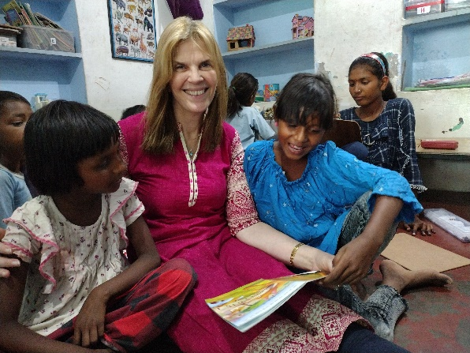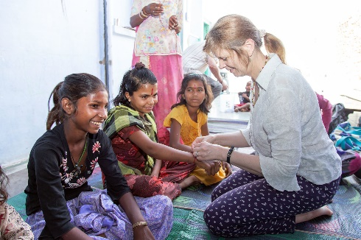

Sue received a very warm welcome at our partnership desert camp school and was impressed by the high standard of academic attainment. The curriculum was rich and varied and the small classes were helping the students to reach their individual potential. In addition, there is some teaching of individual students, or small groups, in order to accelerate learning and progress. Many of the students were undertaking accredited examinations at a local school. They had been well-prepared and seemed confident as they left the school to attend the exam centre. The school is at capacity and an extra classroom has been created on the flat roof. This rooftop classroom is surrounded by a low wall and is carefully shaded from the sun by a permanent awning; there is also a large fixed fan. The older students tend to work with their teacher in the rooftop classroom because it is quieter there and more conducive to learning.

The wellbeing of pupils is a high priority, as illustrated in our previous newsletter, and Sue was happy to observe many examples of excellent pastoral care during her visits.

Special Needs

Following a long search for suitable new premises, the children and staff have settled well into their new rented school premises after leaving our good friend Laetitia's home at the end of October. The new school is a most welcoming building with three classrooms, a therapist room, a kitchen and office. Outside there is a playground area which offers space for play and for creative activities. There are currently 53 pupils with four wonderful teachers, plus a physiotherapist and a speech therapist, both of whom are appropriately qualified, skilful and experienced.
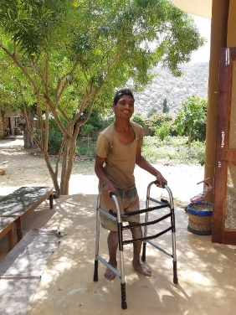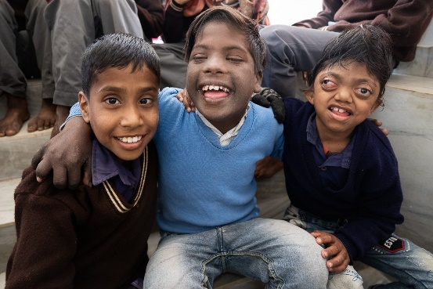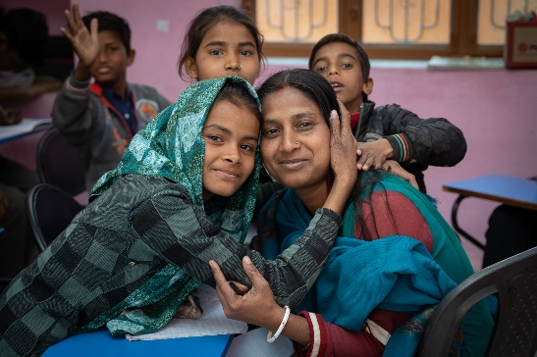
The Headteacher has now arranged for a number of the older students to try some work experience at a hotel - where they learn basic skills such as helping to clean and prepare rooms ready for arriving guests, cooking breakfasts or serving meals - and at a beautician’s premises, where girls are learning to create traditional henna patterns on customers’ hands. Another exciting development has been the introduction of outdoor activities beyond the school grounds, such as short hikes for those pupils able to walk and picnics to explore nature in local beauty spots.
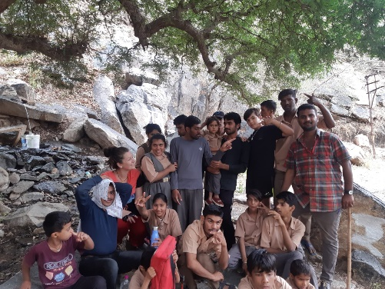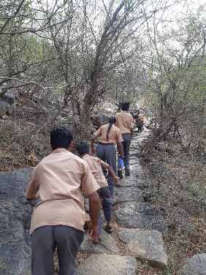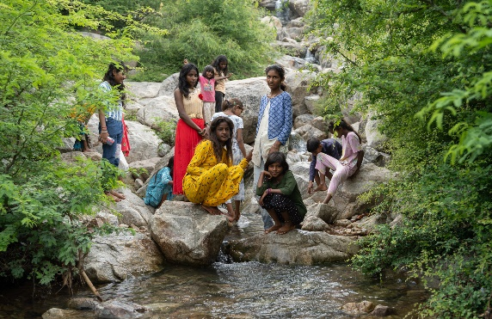
In the long term, we would like to extend the mission of the school to incorporate boarding facilities, as there is a great need for such provision. Our lovely friend, Laetitia, is a very experienced Special Needs teacher, living in Pushkar and volunteering at the school; she is to explore the potential for this development of our provision for pupils with a wide range of neurodevelopmental disorders, frequently coupled with physical disabilities; the needs of these children are therefore very complex and the ability to offer the provision of residential schooling, with increased access to physiotherapy and other specialised provision, would be of enormous benefit to such children.

Finally, A New Part-Time School!

As previously reported in our newsletters, rental payments in Pushkar have increased significantly, so it is wonderful to be able to tell you that one of our partnership NGOs, Pushkar Children Trust, has been able to fund and build a part-time school or ‘Project House’ in Pushkar and that it is now open and normal activities have resumed there; these include the provision of part-time learning, after-school homework support from an experienced teacher for those pupils sponsored to attend mainstream school, creative and play activities and a daily hot meal. Sue was given a tour of the newly completed project house by the founder of Pushkar Children Trust, Dr Trine Obel, who was also visiting Pushkar in October. It is a truly remarkable achievement.

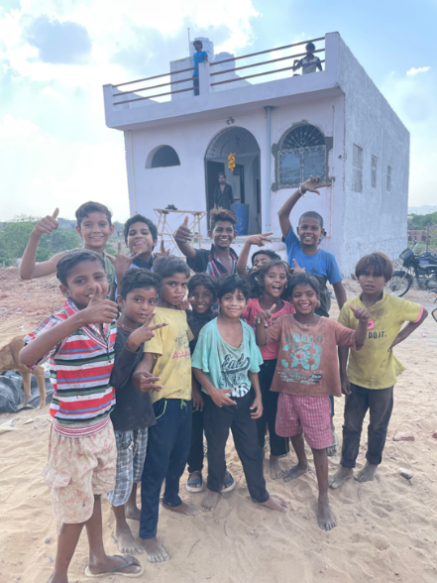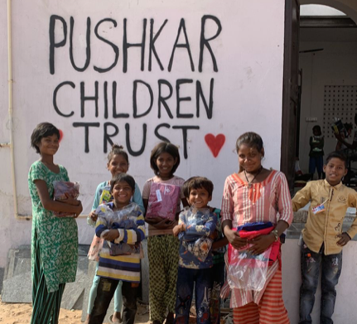

Thanks to funding from The Dragonfly Schools Foundation, curriculum materials, outdoor sports equipment, a bicycle, tables, mats, room fans and kitchen items were purchased for the new project house. It is not possible for our charity to purchase land or to fund building costs, but we continue to fund the part-time teacher’s salary and to provide both educational resources and furnishings as the part-time school house develops.

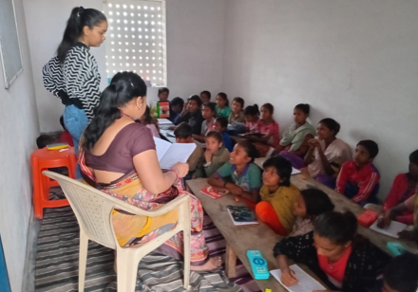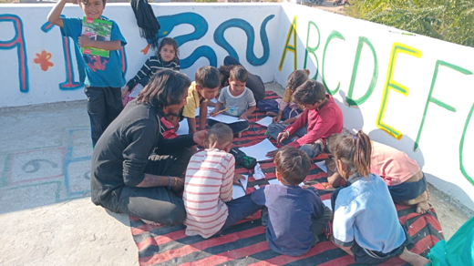

The new project house continues to build upon the considerable successes and achievements of its forerunner as a joyful and caring place where children thoroughly enjoy learning and the company of their friends, where their wellbeing is paramount, where they are safe and where they continue to thrive.

Traineeships at TOLFA

We currently sponsor the 3-year traineeships in Animal Care for Rehman, Jatin and Rounak at the TOLFA hospital. The very high standards of care and the exceptional skills of staff at this amazing hospital have been recognised internationally, with awards from many prestigious veterinary bodies, including the Royal College of Veterinary Surgeons and CEVA, so the standard of these traineeships is equally high.
Rounak’s favourite part of his course is working with the dogs. He used to volunteer at TOLFA and helped the Rescue Teams bring sick or injured animals back to the hospital. He is very committed to his work with dogs and has two rescue dogs at home which he adopted from TOLFA. His Mentor says he has great empathy with the animals in his care and is highly motivated and very keen to gain his qualification. He told Sue that he is very proud to work at TOLFA.
Jatin was also very keen to tell Sue how much he loves his work at TOLFA, especially working with the teams who give treatments to the dogs in the kennels. He is now adept at giving rabies vaccines, administering a wide variety of treatments and assisting the vets in theatre. His Mentor says he is a quick learner who always treats the animals with great kindness and gentleness.
Rehman particularly loves working with the large animals, including donkeys, horses, camels, cows and oxen. He is not afraid of their size and knows how to behave around them. Rehman enjoys coming to work and has many friends at the hospital. His Mentor said he is a highly motivated and capable young man with great confidence and intuition as well as a very kind heart.
We are sad to report that Raj, our fourth trainee, left his course suddenly and unexpectedly. Teenage boys such as Raj have many responsibilities and pressures placed upon them within their families, often being the sole breadwinner and carer for younger siblings and older grandparents, and it may be that he is needed at home because of this. For example, one of our first trainees, Ghanu, was the head of the family at 15 years of age, responsible for the care and wellbeing of his sick mother and grandmother as well as his four younger siblings. We are trying to discover the reason for Raj’s departure and will offer him every opportunity and incentive to return to TOLFA and complete his training, either now or at some time in the future.

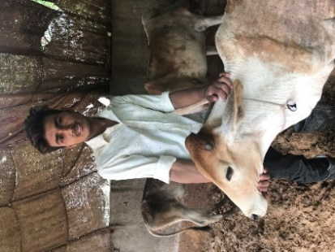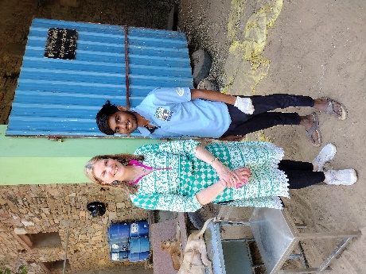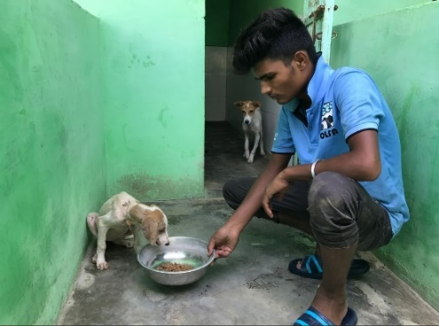
Rehman Jatin Rounak

Our earlier sponsored trainees, Ghanu, Rahul, Pritam and Patrick, are all now enjoying life in full-time employment as fully qualified, highly skilled and much-valued members of the TOLFA hospital team. It’s been a great success story!
Blessed and Thankful

We never cease to feel truly blessed by the keen interest, enthusiasm, kindness and generosity of everyone who supports our charity’s work in every way. Our progress, and that of our children, as ever, depends entirely upon your much-valued support and we are deeply grateful to you all for turning our hopes into our pupils’ achievements.

We are indebted to Pete and Sarah at Practice Supplies Ltd in Stillington, for donating a brand-new, high-quality printer to our charity and supplying us with free inks for our increasing printing needs. This gives a wonderful boost to our charity’s ability to advertise and promote our work and to stay connected to supporters who request hard copies of newsletters, other informative information, promotions and invitations. Our heartfelt thanks to you, Pete and Sarah, for your amazing support!

Our now traditional Christmas Coffee Morning was yet another most enjoyable day and fundraising success, raising a fantastic £1,212 plus an additional £276 in Gift Aid. Our heartfelt thanks to Margaret, Caroline, Ruth and our friends Judith Powell, Jane Hall and Lorraine for all the truly wonderful baking and to Caroline, Bethan, Ruth and Lottie for your help on the day. Grateful thanks also to Thomas the Baker for donating 50 mince pies for the event, to our friends Jeremy Comfort, Ann Angood, Gill Harris-Douglas and Jo Evans for donating items to sell and to all who came along on the day or sent a donation instead.

Our grateful thanks to the very many individual supporters who have made single or multiple one-off donations, or regular Standing Order donations. We are also deeply grateful to the Charitable Trusts, businesses and communities who have come to our aid so generously since our previous Newsletter: K Home Engineering, Practice Supplies Ltd, Thomas the Baker, The Fulmer Charitable Trust, York Vikings Rotary Club, Brandsby WI and Baddow Dental Practice.

If you can support our work, you can donate online via our website, by post to Stonecroft, Main Street, Yearsley, York YO61 4SL, or by bank transfer using the following details:

Account Name: The Dragonfly Schools Foundation
Account No: 25315987
Sort Code: 05-09-94

If you are able to Gift Aid your donation, please do, as charities can claim a further 25% of the value of your donation from HMRC without additional cost to you. You can tell us you are Gift Aiding simply by emailing us at enquiries@thedragonflyschoolsfoundation.com or downloading and completing a Gift Aid form from our website and sending it to us.

Thank You!
*When donors wish to remain anonymous, we always respect your wishes and your privacy. We like to send out our individual letters of thanks but contact details for some donations are impossible to trace, due to the General Data Protection Regulation rules which came into force in 2018. We therefore apologise for this general ‘thank you’ to you in our newsletters. However, we will be delighted to send you a private acknowledgement and thank you for your support upon receipt of your contact details which we promise not to keep or use to make unsolicited contact with you in the future.

www.thedragonflyschoolsfoundation.com
Registered Charity in England and Wales No 1170021

