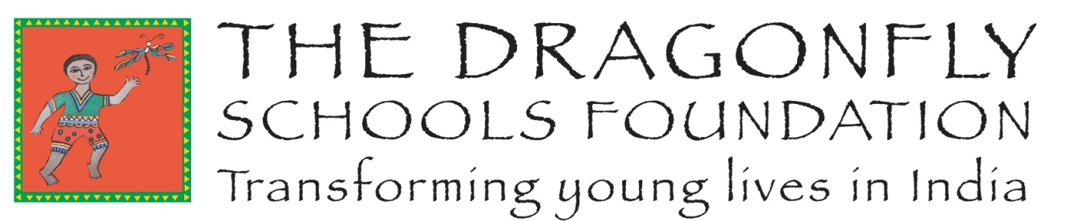

Child Protection Policy
- Introduction

The Dragonfly Schools Foundation (TDSF) supports children and adolescents from marginalised communities living in the Pushkar area of Rajasthan, Northern India. Its aims are as follows:

- To create partnerships with already established, but underfunded and under-resourced schools serving our chosen beneficiaries in our chosen area of operation.

- To provide part-time education to those children who are unable to access full-time education.

- To develop and fund training programmes for young people.

For the purpose of this policy, ‘children’ are defined as those who are 18 years of age or younger. The term, ‘Child Protection’ is used to describe the responsibilities and activities undertaken to ensure that children and adolescents are not abused or maltreated.

The role of the Child Protection Coordinator (CPC) is a senior staff member who will ensure that this Child Protection policy, and the contents therein, is adhered to and who will report any incidents relating to child protection to the appropriate authorities. Where appropriate, a deputy CPC will be nominated to assist with this role.

TDFS is determined to work with our Partnership Schools and Trainee Organisations and take all the necessary steps to manage and minimise any potential risk of child abuse to the children and adolescents with whom it comes into contact, and to protect them from harm.

Code of Conduct for our Partnership Schools and Trainee Organisations:

- Treat all children with respect regardless of age, race, religion, gender, sexual orientation or disability.

- Never behave in a physical or verbal manner which could be construed as inappropriate,
abusive or demeaning.

- Never engage in sexual activity with any of the children in our partnership schools or trainee organisations.

- Take seriously all complaints of child abuse, from whatever source, and report it, or any breach of this code or of the Child Protection Policy, to the CPC.
- Always use any communications or recording technology or social media appropriately, and never to exploit, harass or put children at risk, or to access child pornography via any medium or from any source.

- Never employ physical punishment as a disciplinary tool.

- Never employ children for domestic or other work which is inappropriate to their age or developmental stage, or which interferes with access to education or recreation, or which places them at risk of injury.

- Comply with all relevant Indian laws.

- In photographic or video images, children should always be portrayed in a dignified and respectful manner and not in a vulnerable, sexually suggestive or submissive manner.

- In photographic or video images, there should be no identifying information of a child used in the publication of images.

- In photographic or video images, children should be portrayed as part of their community.

- Adopt good practise and comply with Indian safeguarding measures when adopting new staff to the school.

The TDSF Child Protection Policy is compliant with local and international child protection legislation expressed in the following Acts:

- United Nations Convention on the Rights of the Child - Child Abuse Prevention and Treatment Act, 1974 (USA)
- The Children’s Act 1989 (UK)
- UK Charity Commission Policy Paper “Safeguarding Children and Young People” 2014
- Rajasthan State Child Policy 2008, (India)
- Juvenile Justice (Care and Protection Act) 2000, (India)
- The Protection of Children from Sexual Offences, 2012 (India)
- Rajasthan State Policy for the Girl Child, 2013 (India)

While it is not possible to eliminate all risk of child abuse, proactive management can minimise the likelihood or incidence of child abuse

- What is child abuse?

Abuse happens to male and female children of all ages, ethnicity and social backgrounds, abilities, sexual orientation, religious beliefs and political persuasion. Child abuse includes physical, sexual and emotional abuse, neglect, bullying, child labour and domestic violence.

Physical abuse
When a person purposefully injures or threatens to injure a child or young person.
This may take the form of slapping, punching, shaking, kicking, burning, shoving or grabbing.
The injury may take the form of bruises, cuts, burns or fractures.

Emotional abuse
When a child is repeatedly rejected or frightened by threats. This may involve name-calling, demeaning behaviour or continual coldness from a parent or carer, to the extent that a child’s physical and emotional growth are affected.

Neglect
Neglect is the persistent failure, or the deliberate refusal, to provide a child with clean water, food, shelter, sanitation, supervision or care, to the extent that the child’s health and development are placed at risk.

Sexual abuse
This occurs when a child or young person is used by an older or bigger child, adolescent or adult for his or her own sexual stimulation or gratification - regardless of the age of consent, locally. These can be contact or non-contact acts, including threats and exposure to pornography.

Child-Sex Tourism
The charity called ‘End Child Prostitution, Child Pornography and Trafficking of Children (ECPAT) International’, defines child-sex tourism as: “...the commercial sexual exploitation of children by men or women who travel from one place to another, usually from a richer country to one that is less developed, and there engage in sexual acts with children, defined as anyone aged under 18 years of age” (ECPAT International, 2006).

Child Marriage
UNICEF defines child marriage as marriage before 18 years of age and considers this practice as a violation of human rights. The harmful consequences of child marriage include; segregation from family and friends, limiting the children’s interactions with their community and peers and restricting opportunities for education. In 2006 the government of India passed the Prohibition of Child Marriage Act, 2006. If any of our Partnership Schools or Trainee Organisations learn that a child, under the age of 18 years, is getting married, they must inform the police and other appropriate authorities. As part of the school curriculum, children should be made aware that child marriage is illegal in India and be informed of the work of CHILDLINE. Should a child fear that they are to be married under the legal age, they can ring CHILDLINE. The number is 1098 and is a 24-hour, free, emergency phone outreach service for children in need of care and protection. When a child contacts CHILDLINE, members of the CHILDLINE team, together with the appropriate authorities, will negotiate with the family and prevent the proposed child marriage.

Bullying
Bullying is the inappropriate use of power by an individual or group, with intent to cause injury, either physically or emotionally. It is usually deliberate and repetitive. The bullying may be physical or psychological (verbal and non-verbal). Physical bullying includes pushing, hitting, punching, kicking or any other action causing hurt or injury; verbal bullying includes insults, taunts, threats and ridicule; psychological bullying includes physical intimidation and ostracism.

Exposure to domestic violence
Domestic violence occurs when children and young people witness or experience the chronic domination, coercion, intimidation and victimisation of one person by another by physical, sexual or emotional means within intimate relationships [adapted from the Australian Medical Association definition].

Particularly vulnerable children
Child abuse takes place not only within the family environment, but also outside the family, including: in institutions, at work, on the streets, in war zones and during emergencies.

- How can we minimise the risks of Child Abuse?

TDSF recognises that there are a number of potential risks involved in the teaching of vulnerable and disadvantaged young people in its Partnership Schools and Trainee Organisations. Therefore, the Code of Conduct (see above) and the following practices stated below, will serve to ensure that children are protected as much as possible:

- A Child Abuse Incident Reporting Sheet has been created (see Appendix 1) and the Headteachers/Managers of our Partnership Schools and Trainee Organisations are aware of its existence and have a responsibility to ensure that their staff - employed or otherwise - are aware of it, and will use it to record any child protection concerns.

- Child Protection training and a detailed introduction to the policy will be given to all staff, so that they are vigilant in the pursuit of protecting children. This training can be provided by the TDSF Directors, at the request of the Partnership School or Trainee Organisation.

- A Child Protection file will be provided by TDSF to all our Partnership Schools and Trainee Organisations. This file will not only contain copies of the Incident Reporting form, but will include Child Protection staff training records, the Child Protection policy and other relevant materials. This file must be available to the Directors of TDSF in order to monitor Child Protection policy and procedures.

- There will be a named Child Protection Coordinator (CPC) in each of our Partnership Schools and Trainee Organisations. The CPC is responsible for monitoring Child Protection issues and facilitating policy implementation, staff training and reporting child abuse to the relevant authorities.

- What happens if a child talks spontaneously of experiences that give cause for concern?

Staff and volunteers working in our Partnership Schools and Trainee Organisations are advised to listen to, and to take seriously, any disclosure of abuse. They should then inform the CPC and record the concern on the Child Abuse Incident Report Form [see Appendix 1]. The CPC will contact the appropriate Indian authorities where necessary. The schools and trainee organisations will work together with other agencies when there is a Child Protection issue.

I declare that I will abide by this Child Protection policy.

Signature of Head or Manager of Partnership School/Trainee Organisation:

---------------------------------------------------------------------------------

Print Name ---------------------------------------------------------------------------------

Date: ---------------------------------------------

This policy will be reviewed by UK Trustees on an annual basis.

www.thedragonflyschoolsfoundation.com

enquiries@thedragonflyschoolsfoundation.com

Registered Charity in England and Wales No. 1170021

Appendix 1 – Child Abuse Incident Report Form 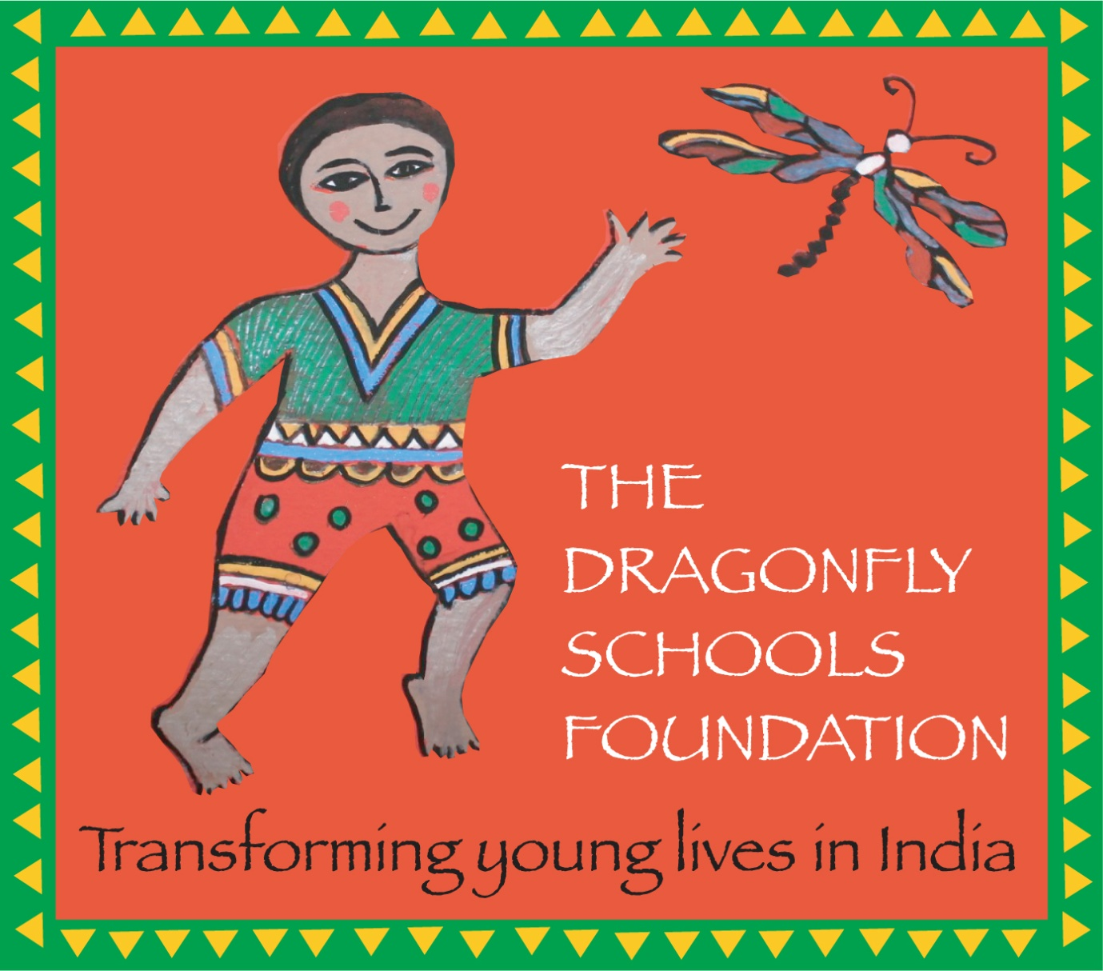

Name of child making the disclosure:

Date of the disclosure:

Time of the disclosure:

Details of the disclosure: [When did the incident happen? How many times has it happened? How was the child hurt? Any physical marks on the child? What size is the mark?]

Action taken and by whom:

Name of Person Writing Report:

Signature of Person Writing Report:
Child Abuse Incident Report Form

Second Sheet should it be required

Name of Person Writing Report:

Signature of Person Writing Report

Registered Charity in England and Wales No. 1170021

